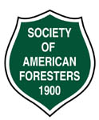

OREGON SOCIETY OF AMERICAN FORESTERS

# 4033 SW Canyon Road • Portland, OR 97221 • 503.224.8046

CHAPTERS: Blue Mountain • Capitol • Central Oregon • Central Oregon Community College •

Columbia Gorge • Coos • Emerald • Marys Peak • Mount Hood Community College • Oregon State University • Portland • Shasta-Cascade • Siskiyou • Tillamook-Clatsop • Umpqua